Week 4 Reading and Assignments
Complete the following reading early in the week:
- Week 4 online lectures
- From your textbook, Exploring Digital Cinematography, read the following chapters:
  - Traditional Lighting Techniques
- Optional viewing:
  - Cabinet of Dr. Caligari (1919)
  - Bioshock Gameplay and Intro
- Review the text 3ds Max 2010 Bible as needed to reinforce and expand on the concepts and techniques required for this week’s assignments.
Assignment Summary: Week 4 | Due Date
Assignment 1: Discussion Questions | Friday, June 4, 2010
Assignment 2: Final Project: Remodeling | Sunday, June 6, 2010
Assignment 3: Use of Lights and Colors | Tuesday, June 8, 2010

Week 4 Overview
Together, we covered a journey over the past three weeks—discovering and using various aspects of camera and lighting in films, animations, and games. We experimented with editing and transitioning techniques, and we explored some of the effects, moods, and emotions that we can bring into the scenes we create.
With experience, you will acquire new skills and continue to give shape to your creative imagination, building a virtual world for your viewer. However, it is important that you build this imaginary world on a sound foundation. By thorough preproduction planning, you can ensure a strong base for your scenes. This week, we will revisit the importance of the scene planning, specifically how it helps us to understand the unique requirements of our scenes.
In previous lectures, we learned about some of the lighting and camera techniques used in films and animations. But are the camera and lighting techniques used in films really different from the techniques used in games?
In addition to scene planning, this week we will also explore the use of lights and camera in games.
Learning Outcomes:
Know how to use the essential components of the software animation environment to create compelling imagery.
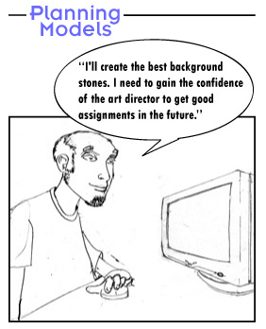
Importance of Scene Planning
Scenes in a movie are planned from the day the project is conceived. Each scene is carefully planned to achieve correct timing of action, appropriate lights, colors, camera angles, foreground and background elements, and the highlighted locations. In addition, computer graphic (CG) scenes are also carefully planned for the modeling, texturing, and rendering time of the elements. Each element is planned for a specific polygonal count and resolution on the screen.
To understand the importance of these aspects of planning a CG scene, let's begin with the example of a young and talented CG artist, Bob.
Modeling—Story I
Bob was a young and energetic CG artist. New to the business, he was eager to make sure that everything he modeled looked great on the screen. He got his first assignment as a modeling artist for a prestigious company.
The first scene of the CG movie was to be shot in a stone-filled canyon. For this shot, Bob was given the task of modeling the background stones. On consulting the art director of the production unit, Bob discovered that although the stones would be seen in all the scene's shots, he should only be concerned with the first shot in which the stones are in the background.
Eager to be noticed for his work and to get an opportunity to move on to more ambitious subjects, Bob decided that he would model the best stones ever featured in a scene. He decided to model the stones in high detail so that they could be rendered from any angle and from any distance. After all, if a stone looks good in a close-up shot, it should also look good from a distance!
Going by this premise, Bob worked hard to add the minutest details to the models. The task was finally due and the technical director who was responsible for assembling the shot approached Bob for the stones to be used in the first shot of the scene.
The next morning Bob checked his e-mail and found a message from the technical director, who plainly stated that the stones were unusable. They were so high in polygonal count for their intended use that she was unable to render a single frame at a rate that was practical for the current schedule. She had to stay late and personally remodel them for the texture map artist who needed them that morning so that the project could stay on schedule.
When Bob consulted the technical director about the problem with the models, she calmly showed him her monitor that held a wireframe image of the scene to which he contributed. The scene was a 3D representation of a canyon, as the art director conveyed to the CG team through concept drawings and production paintings. The scene contained stones in the foreground and midground. Placeholder boxes showed where the main characters would be placed later. The stones in the foreground and midground were made of a wire mesh that was easy to see through and simple in construction. In other words, the wire density on each of these models was low. However, Bob's stones were a dense tangle of the wire mesh that was impossible to see through to make out the individual stones. On moving the model in 3D space, a noticeable lag occurred between the time that the mouse moved and the machine responded. Bob's background stones were the problem!
This incident taught Bob an important lesson! He was now aware that every shot was a different situation; each situation demanded different levels of detail from each of its assets and in relation to its proximity to the camera. Learning from this experience, Bob went back to work with renewed confidence and enthusiasm.
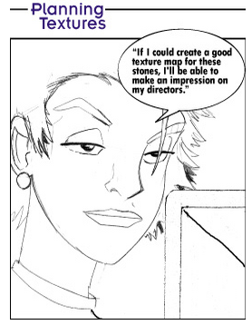
Texturing—Story II
From Bob, let's move on to Cheryl, who was working as a texture artist for the same production as Bob.
Cheryl knew that she would be working on a model that Bob created. The technical director with whom she and Bob had been working told her where to obtain the models on which to apply her texture. Cheryl opened up the models and was surprised to see that they were low in polygonal detail. Therefore, she began her task of painting the most detailed and beautiful stone texture map she could.
Cheryl understood that the stones would be in the background but, like Bob, was hoping to make a name for herself. Because the models were so low in detail, she decided that she would make up for it by creating an extremely detailed and high-resolution texture map. After all, they were working in movies now, and she knew that scenes in a CG movie are always created in high resolution. Thus, she created the textures that applied correctly to the geometry with minimal stretching and finally sent the files on their way.
The next day at the studio, the technical director pointed to the screen in front of her. On the monitor, Cheryl saw a looping animation of the scene that Cheryl and Bob had been working on. It looked great! Cheryl was happy and amazed. However, as her eyes went to the stones for which she had painted and applied the texture maps, she saw something strange happening. The textures she had painted looked as if they were trying to writhe and squirm their way off the geometry. The technical director saw that Cheryl noticed the problem. She explained to Cheryl that the strange movement was happening because the stones were far too high resolution for their intended purpose.
The team was rendering the film resolution at roughly 2,000 pixels. Cheryl's texture maps were too large to be applied to objects that looked small on the screen. In this case, the computer attempted to render the stones with the texture map much larger than the final output resolution of the frame. Therefore, to display the proper size of the texture in relation to the entire frame, the computer decided which pixels of the texture to display and which pixels to hide. In other words, Cheryl's work asked the computer to try to display 2,400 pixels across a part of the image that was no more than a 1,000 pixels across. Which of those 2,400 pixels would the computer show, and which pixels would it not?
The computer could not determine any order and, thus, it displayed it at random, which resulted in the "frying" that Cheryl witnessed.
Cheryl had not anticipated such a factor when she deciding the texture size. She simply assumed that bigger was better, and that the studio's expensive high-end hardware could handle the resolution that she used.
Cheryl failed to see her texture as a part of the scene and ignored aspect planning in context of the scene and available resources.
The Top-Down Diagram
Cheryl had worked hard to create the best textures for the stones in the scene, but the stones were unusable. How could Cheryl plan the proper resolution when she was given nothing more than a storyboard panel on which to make such an important decision? At the same time, Bob, at his own desk, was asking himself the same question. The answer is simple: A top-down diagram.
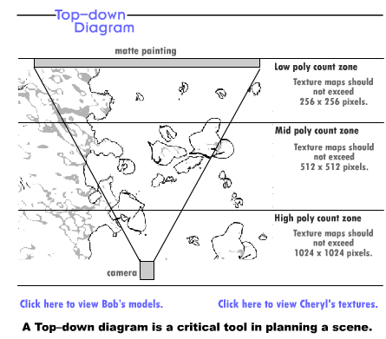
In a CG environment, a top-down diagram is a tool that the production team uses to understand the elements of a scene and how to model them. The top-down diagram can be simple or complex. At its simplest, it indicates the location of the camera in relation to the objects in the scene, as well as where it moves to during the action of the shot. It can be as simple as a developer or director jotting down notes for his crew to gain a better understanding of where to place lights, props, and set items.
A developer or director uses a top-down diagram to decide which item can be a simple geometry with a texture map effect and which item must be in high polygon count geometry, and vice versa. The texture artists also use this diagram to decide the level of detail and resolution for the texture maps, while remembering that most texture maps never need to be larger than the size of the frame's final output resolution.
A developer or director can also use a top-down diagram to ascertain the elements closest to the camera in the scene and plan the scene accordingly. The elements closest to the camera should be the most detailed and well executed, while the elements at a distance, at the edges of the frame, or away from the focal point of the frame do not need to be as detailed, because the viewers will not have their eyes on them.
However, like a storyboard, the importance of a top-down diagram varies from one developer or director to another. Some developers or directors use it religiously, others use it without realizing that it is a standardized convention of scene planning, and some may not have heard of it.
Along with the storyboard, concept art work, or production painting, the top-down diagram is a useful and sometimes critical tool, that artists use to plan where to spend their resources most effectively, the most valuable of which is time!

Lights in CG vs. Real Life
After learning from the experiences of Bob and Cheryl, we can say that extensive planning is essential for any production. As we are dealing with the visual medium, any imperfection in scene is easily and clearly visible to the viewer. If not properly planned, a single component can destroy the cumulative effect of the scene. One such component of our scenes is light.
A popular saying in the world of cinematography is, "Never say it if you can show it." In movies, lighting creates a sense of three dimensionality and adds emotional color to scenes. Developers or directors often use lighting for the dramatic emphasis of the scenes. For example, with the use of harsh lighting, you can make your characters look angry or distressed; on the other hand, with the use of soft lighting your characters can be depicted in a romantic mood.
As a developer or director, you can use many methods to experiment with the lighting in your scenes. However, let's first get familiar with some parameters of light in CG.
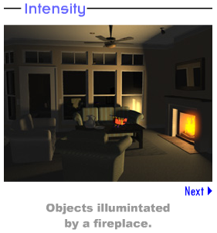
In CG, light is described and controlled through a set of parameters as described below.
Intensity
The intensity of light determines how brightly an object is illuminated when placed at a distance from the source of light. For example, an object in a room lit only by a candle looks dull. On the other hand, the true and vibrant colors of object are brought out in a properly illuminated room.
Most 3D software has a value change option that is used to manipulate the value of the intensity or brightness of light. For example, in 3ds Max the "multiplier" is used to select the value of light intensity. The higher the multiplier value the brighter the light or intensity will be.
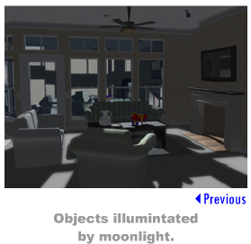
Color
The color of the light is partly dependent on the source that produces it. For example, while the sunlight is yellowish-white, the moonlight is bluish-white. The colors of light can also shift because of rays that travel through the suspended particles in the atmosphere.
You can change color in CG by using a set of standard color manipulation controls on a moving value selector. All graphic software support color manipulation and control the power to change hue, value, and saturation of the light's color. On the other hand, in live-action films, color manipulation is limited to colored gels that are placed in front of the conventional lighting fixtures. Using these gels creates lighting scenarios in which color is difficult to control.

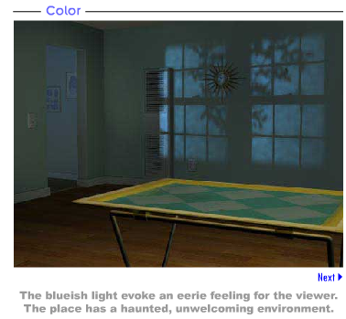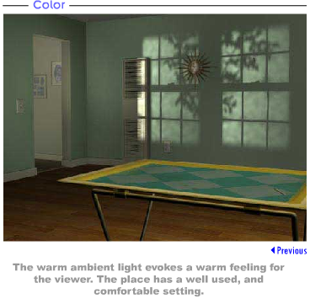
Decay
Decay is the rate at which light fades as it moves away from its source. This effect is often the result of light rays that disperse and eventually dissipate due to the environmental factors such as dust, fog, or other airborne particulate.
The rate of decay of light is inversely proportional to the distance from its source. The strength continues to diminish as light rays travel farther away from the source. Therefore, if you measure the strength of a light ray four feet away from its source, it would be 1/4 times as strong as it was when it left the light source. As it moves further away, the strength will further decrease.
Attenuation
Like decay, attenuation is the rate at which light diminishes in intensity as it travels farther from its source.
In CG, not only can you control the attenuation, but also you can set the beginning and the ending range of the attenuation value. You can more precisely set up a way of light decay or gradation by manipulating attenuation than by using the decay feature.
Hot Spot
Hot spot is that point on an object where the highest intensity of the light rays hit when a ray of light strikes it. The light is hottest and brightest at this point.
In CG, pushing and pulling the appropriate slider can easily manipulate the hot spot parameter. On the other hand, in real life the reflectors are narrowed to concentrate the beam to achieve the same effect.
Fall Off
Fall off is the rate at which the value fades to black as the source of light moves away from the hotspot.
This parameter is also easily manipulated in CG. The real-life equivalent would be opening the barn doors on a traditional film light.
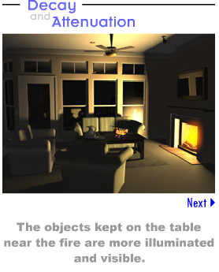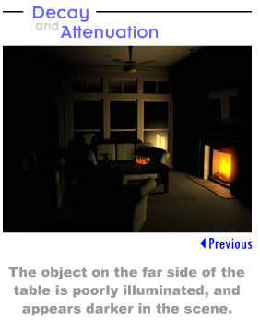
Films and Games
Like films, games are built and developed on the creative visualization of a director or the developer. However, until human potential discovered a way to make it visible and workable, visualization was just another word for the creative process. Films turned human dreams into reality; an imagination became a vision! As our desire for interactivity increased, we shifted our focus to games.
In games, in our desire to bring in real-life effects, emotions, and the pleasure of films, we tried to use camera and lighting as we learned to use them in films. Is camera and lighting different in games? Wouldn't the camera and lighting techniques in games produce the same effects as they do in the films?
On a broad perspective, games do not differ much from films. However, the element of interactivity in games demands a difference in the basic treatment of camera and lighting during the development.
Let's try to find out how camera and lighting are used in games.
Camera in Games
In the previous weeks, we have discussed the movement and the placement of the camera in a film or an animation sequence. The effective camera placement and movement connect the viewer with the scene. Your viewer starts relating with the characters and the events of the story as he or she becomes comfortable with the scene.
This line of thought does not change in the world of games! Effective camera movement and placement is as important in games as in the films. However, the key to understand the camera use in games is in understanding the game genre.
As you know, genre refers to the type of game being played. For example, in the real-time strategy (RTS) games, the player is the master of a team of characters. The player manipulates these characters to gather resources and build fighting forces against the enemy. On the other hand, in first-person shooters (FPS) games, the player is inside the game character and faces the enemy eye to eye.
Many genres of games exist, but RTS and FPS represent two distinctly different camera perspectives so let's examine these two genres in particular.
Camera Placement in the RTS Games
In real-time strategy (RTS) games, the camera is generally placed in an extreme long shot and at a ¾ angle. What purpose does this placement serve?
As you learned in the previous lectures, high-angle camera placement gives the viewer a feeling of knowing something that the characters in the film do not. The same is true for the games.
It is crucial for the playing experience of the player that he is given a proper perspective in order to manipulate the game world. In RTS games, a player is a god-like figure who maneuvers the characters and other elements of the game from a distance. Therefore, in such games, the player must have the power to see things that other characters in the game cannot. By placing the camera high up, you can give the player a proper perspective to play the game effectively.
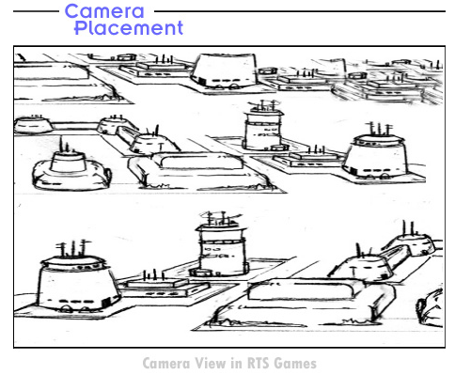

Camera Placement in the FPS Games
In the first-person shooter (FPS) games, the player is on the ground like the other characters in the game.
The name of the genre itself suggests the view of the camera in the game. The game is a first person's point of view. The player experiences the game from the point of view of the game character. Comparing this view with your understanding of the film camera, you find that this first person point of view promotes the feeling of personal identification. The player distinctly experiences the feeling of being in the game and reacts accordingly.
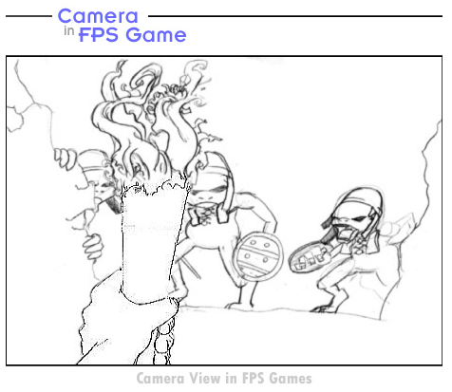
While RTS entails generals, kings, and heads of state who manipulate the pieces on a map of a battlefield, the FPS is the role of a foot soldier that fights the war at a more intimate level. Both roles offer unique challenges for the player. A general is the one to decide where to move the regiments to hold the line of defense, while the foot soldier is the one on the line defending it!
Camera vs. Marketing Strategy of Games
Marketing strategy for a game is an integral part of the decision that you, as a developer or director, make to select the camera placement in your game.
As a developer or director, you need to place a camera based on the level that you want the player to identify with the game character. In the games with a recognizable and iconic character, the camera is usually placed at a distance so that the defining attributes of the character are clearly visible to the player. For example, a character such as Lara Croft has built an entire franchise, Tomb Raider, on its looks. If you have a popular character like Lara Croft in your game, you can create a much better market for your game by making her more visible on the screen than by using the camera angles that would hide her attributes. Therefore, for such games, the camera is pulled to a third-person view in which the protagonist is in view, even though the game mechanics are virtually the same as in the FPS game.
The basic principles of the camera placement in games are the same as the principles of camera placement in movies. As up-and-coming game developers, it is important that you understand the mechanics of the human brain when it processes the information that a camera presents.
Light in Games
Games present players with a unique story and visual experience. The players become active participants in the events of the game's story. The player decides the settings, the difficulty levels, and in some games, the characters. Once the player decides these parameters, the screen must instantly be updated according to the choices made. Because of the demands of this instant reaction, the rendering of the 3D geometry in a game must be done at a rate of roughly 45–60 frames per second. On the other hand, a single frame of a movie such as Toy Storytook about eight hours to render. By comparing the eight hours of rendering time for a movie frame with the rendering time of 1/60 of a second for a game, you can get an idea of how the rendering time of a game must be economized to meet the speed required by games.
How Does this Affect Lighting?
Let's examine how lights are calculated in CG. The computer calculates the value of the light rays according to their strength and placement in the scene. Certain features of light take more time to render. Effects such as fog, smoke, shadows, and bouncing lights add to the time that computer needs to calculate the light beams in a scene. The more lights you add to the scene, the more complex the calculation becomes. This results in a slower rendering time per frame.
Fake Lights
In games, the need for speed has resulted in some ingenious solutions to convey the lights. Depending on the technology on which a game is running, some games don't even have true lights. In such games, the game code calculates the direction and intensity of the light and lightens the textures on the models to simulate a lit environment. This calculation occurs before the screen displays any models, thereby drastically reducing the time required for rendering. This real-time lighting setup demands that all the objects in the scene be essentially self-illuminated.
Because lights are no longer calculated by the computer, the shadows are not rendered or extracted from the light source; instead, the game code fakes them. The game engine usually calculates the placement and intensity of the shadows in the scene and "bakes" them into the ground plane. Visualize a scene with a tree on the side of a hill, and the sun roughly half way to its highest point, casting a long shadow of the tree across the ground. Because the computer is not actually calculating a light, the game code must estimate where the shadow might lie across the ground plane and darken the ground texture or bake in the shadow to simulate the look of a cast shadow. As a result of being baked into the texture, the shadow is now a permanent part of the ground texture. If the time of day in the game scene changes, the texture must essentially be swapped out and replaced with a fresh one that no longer has that shadow as a part of it.
Real Lights
Some games use real lights, but on a limited scale. While using real lights, a game developer must remember that the more real lights in a scene, the slower the frame rate. Therefore, use real lights only for the most crucial effect or the pivotal moment in the game story.
When you play a CG game, roughly 80–90 percent of the lights that you see are not real lights. As technology grows and computer processing speed increases, games will use more real lights, and these cheat effects will become rare. Until then, the process of lighting a scene in a CG game will differ drastically from a CG film.
How does this affect you as an artist who hopes to work in games?
Unlike prerendered films, the aesthetic aspect of the games focuses primarily on ensuring that the textures for your models do not actually have a light playing across their surface. You need to address this issue while painting the textures for your models. Therefore, the effects such as a shadow, which you can take for granted in a prerendered CG, must now be painted into the texture of the model.
Lighting in CG games is different from lighting in CG films. As a game developer, you must consider the limitations of games in terms of their real-time feature before you decide on the lighting for your scene.
Summary
This week's lecture began by re-emphasizing the important aspects of planning, modeling, texturing, and top-down diagram. You then learned the planning aspects of the camera and lighting in the games, specifically how they differ from films.
A saying that is especially popular in TV production is, "The most important phase of production is preproduction." This saying is as true for any field of production or art as it is for TV production. As you observed in the two examples this week, an extensive plan and end-to-end study of this plan can save a lot of production time and help to give form to your imagination.
Remember, if you take care of your planning, your planning will take care of you!
In the previous lectures, you observed and learned how to use camera techniques to bring out the desired intent in our scenes. Lighting, on the other hand, is a vast subject. In fact, lighting is a separate field of study. In the world of animation, lighting plays an important role to enliven the virtual world that you create for your viewers. In the next week, you will continue to study about lighting in detail. At this point, start learning about the lighting features in your 3D software. Start experimenting by changing the light temperature and the intensity, and observe their effects. Think of how you can use lighting to invoke emotions of comfort, happiness, excitement, or horror in your viewer! Study movies and observe where and why the developer or director has used a particular set of lighting to change the mood of a scene.

Assignment 1: Discussion Questions
By Friday, June 4, 2010, go to the Discussion Area and post responses to two of the discussion questions assigned by the facilitator. All responses should be posted to this Discussion Area.
Before the end of the week, begin commenting on at least two of your peers' responses. You can ask technical questions or respond generally to the overall experience. Be objective, clear, and concise. Always use constructive language, even in criticism, to work toward the goal of positive progress. Submit your responses to the appropriate topic in this Discussion Area.
Assignment 1 Grading Criteria | Maximum Points
Response Criteria
Met the criteria for the correct responses to the questions assigned. | 4
Used vocabulary relevant to the current week's topics—at least four terms. | 4
Participation Criteria
Used vocabulary relevant to the current week's topics—at least four terms. | 4
Participated in the discussion by asking a question, providing a statement of clarification, providing a point of view with rationale, challenging a point of discussion, or making a relationship between one or more points of the discussion. | 4
Justified ideas and responses by using appropriate examples and references from texts, Web sites, and other references or personal experience. | 4
Total: | 20
For assistance with any problems you may have when completing this assignment—OR—to offer your assistance to classmates, please use theProblems and Solutions Discussion area located through the left side navigation link.

DQ 1 – Aspects of planning
Discuss the planning aspects that you consider most important in developing a scene. Recall your experiences as a CG filmmaker or game developer. Were there any instances where you ended up reworking on certain parts of a scene? Share the experiences where you could have been benefited from better planning.
DQ 2 – Marketing strategy
What aspects of lighting and camera will you consider while developing a game to enhance the salability of your game in the market?
DQ 3 – Camera Control
As a player would you like the freedom of being able to move the camera yourself or do you think it's better to let the game designers choose the camera for you? Have you played any games that allowed the player to move the camera? Share your experience as a player. As a game developer, what are your thoughts on handing camera control over to the player?
DQ 4 – Scene planning with lights and camera
Why do many developers or directors skip the crucial phase of scene planning? What is the role of a developer or director in deciding the depth of scene planning? How does scene planning help a developer or director to decide the lighting and camera use in a scene? Support your answer with appropriate examples.

Assignment 2: Final Project—Remodeling
Based on the storyboards that you created in W2: Assignment 3, rearrange the camera movement and observe the change in the intent and emotion that the scene conveys. Based on your conclusions from the top-down diagram, remodel the elements of the scene. Rerender the scene at 320 x 240 ppi.
Save your animation following the sample naming convention: Scene_number_First name.mov. Submit your assignment as a ZIP file.
By Sunday, June 6, 2010, post your ZIP file in the W4: Assignment 2 Doc Sharing folder, and post your observations to this Discussion Area. Review and critique the work of at least two other students as early as possible and comment on the way they have used various effects to convey depth and mood. Then, revise your work based on the peer reviews you have received. After incorporating the changes, post the revision by the end of the week, inviting reviewers to comment on your changes.
Assignment 2 Grading Criteria | Maximum Points
Created a rendering of the scene at ½ NTSC resolution. | 12
Modeled the objects in a top-down diagram with conclusions on whether the model needs to be high poly. | 12
Demonstrated an awareness of the emotional impact that the scene conveys. | 8
Demonstrated an effective use of placement and motion using camera movements as a means to achieve the stated intent. | 8
Actively participated in the Discussion Area. | 8
Total: | 48
For assistance with any problems you may have when completing this assignment—OR—to offer your assistance to classmates, please use theProblems and Solutions Discussion area located through the left side navigation link.
ProTip: Please post your files here to the DISCUSSION BOARD
Assignment 3: Use of Lights and Colors
Take two stills that you created in W1: Assignment 3 and incorporate the modifications and suggestions provided by your peers. Rerender them by using high- or low-intensity light and appropriate colors. Observe the change in the intent of the scenes with the change in the lighting and colors in the scene.
Save your stills following the sample naming convention: Scene1_First name and Scene2_First name. Submit your file as a JPG, PDF, or a ZIP containing your files.
By Tuesday, June 8, 2010, post your stills and your observations to this Discussion Area. Review and critique the work of at least two other students as early as possible to encourage them to deepen their thinking about the concepts. Then, revise your work based on your peers' feedback. After incorporating the changes, submit your revision to the W4: Assignment 3 Doc Sharing folder by the end of the week.
Assignment 3 Grading Criteria | Maximum Points
Recreated two different still images from Week 1 by using different light intensity and colors. | 12
Incorporated the modifications and suggestions provided by the peers and provided a meaningful explanation for using or not using them. | 12
Demonstrated an understanding of the use of light intensity and colors to depict emotional intent of the scene. | 8
Actively participated in the discussion and provided constructive comments on responses that other participants posted. | 4
Total: | 36
For assistance with any problems you may have when completing this assignment—OR—to offer your assistance to classmates, please use theProblems and Solutions Discussion area located through the left side navigation link.
ProTip: Please post your files here to the DISCUSSION BOARD

